PROJECT DOCUMENTATION
WEBSCRAPING IN AMAZON USING
MACHINE LEARNING

TITLE: | WEBSCRAPING IN AMAZON USING MACHINE LEARNING
NAME: | HARTHIKA S
COURSE: | DA/DS, Offline
BATCH: | JUNE 2025

TABLE OF CONTENT

1 | INTRODUCTION
2 | AIM OF THE PROJECT
3 | PROBLEM STATEMENT
4 | WEB SCRAPING
5 | DATA UNDERSTANDING
6 | DATA CLEANING
7 | EXPLORATORY DATA ANALYSIS (EDA) - UNIVARIATE
8 | BIVARIATE ANALYSIS
9 | MULTIVARIATE ANALYSIS
10 | SQL CONNECTIVITY
11 | UNSUPERVISED LEARNING
12 | SUPERVISED LEARNING
13 | HYPERPARAMETER TUNING
14 | PREDICTION & CONCLUSION

INTRODUCTION
This project focuses on building and evaluating multiple machine learning models to predict outcomes based on structured data. It follows a complete data science workflow including data collection, cleaning, exploration, feature engineering, and model evaluation to ensure reliable and accurate predictions. Libraries such as Pandas, NumPy, Matplotlib, Seaborn, and Scikit-learn are used for data handling, visualization, and model implementation.
The analysis involves exploratory data analysis (EDA) to uncover key insights, handle missing values, and identify correlations among variables. Several supervised models such as Logistic Regression, SVM, Random Forest, KNN, and XGBoost are trained and compared using metrics like Accuracy, Precision, Recall, and F1-Score. The project demonstrates a practical end-to-end ML pipeline and highlights the importance of data preprocessing and model evaluation in achieving optimal performance.

AIM OF THE PROJECT
The aim of this project is to build an efficient machine learning model that accurately predicts outcomes using structured data through systematic preprocessing, analysis, and model evaluation. It focuses on developing a complete end-to-end ML workflow — from data cleaning and feature scaling to training and comparing models such as Logistic Regression, SVM, Random Forest, KNN, and XGBoost. The goal is to achieve high predictive accuracy while ensuring interpretability and applicability to real-world problems. Through exploratory data analysis (EDA) and performance comparison using metrics like Accuracy, Precision, Recall, and F1-Score, the project identifies the best-performing model and highlights the importance of data-driven insights in improving decision-making.

PROBLEM STATEMENT
The central problem addressed in this project is to develop a reliable machine learning model that can accurately predict categorical outcomes based on structured and often inconsistent datasets. In real-world scenarios, such as predicting match results, customer behavior, or product outcomes, data tends to contain missing values, categorical variables, and varying scales that must be properly preprocessed to ensure accurate predictions.
The key challenge lies in determining which supervised learning algorithm performs best for such datasets when evaluated using consistent metrics. Each model — whether Logistic Regression, SVM, Random Forest, KNN, or XGBoost — behaves differently depending on the data structure, feature importance, and relationships within the dataset. Thus, the project focuses on building a systematic ML pipeline that handles data cleaning, encoding, and scaling before model training and evaluation.
By comparing models across metrics such as Accuracy, Precision, Recall, and F1-Score, this project aims to identify the most effective algorithm for the given dataset and provide meaningful insights into what drives better predictive performance. The problem therefore extends beyond prediction — it emphasizes understanding model behavior, optimizing preprocessing steps, and enhancing interpretability, ensuring that the final solution is practical and data-driven.

WEB SCRAPING
Web scraping is a critical step in data collection for this project, as it serves as the foundation for all subsequent stages, including data cleaning, analysis, and visualization. In this project, the goal of web scraping is to extract structured and meaningful data about Amazon products — such as product names, categories, prices, ratings, reviews, and offers — directly from web pages. This enables the creation of a real-time, data-driven dataset that can later be analyzed to uncover insights about pricing strategies, product trends, and consumer preferences.
Purpose and Objective
The main objective of this section is to automate the extraction of product information from Amazon using Python libraries. Since Amazon does not provide a free public API for such product data, web scraping becomes a practical alternative to gather the necessary information for analysis. The scraping process helps convert unstructured HTML data into a clean, structured dataset that can be stored and used for exploratory data analysis (EDA) and machine learning models.
1. Importing Required Libraries
The notebook begins by importing essential Python libraries such as:
- Requests – to send HTTP requests and retrieve the HTML content of Amazon product pages.
- BeautifulSoup (bs4) – for parsing HTML and extracting specific elements such as product titles, prices, and ratings.
- Pandas – to organize the extracted data into tabular format for easier manipulation.
- Time – to add delays between requests to avoid IP blocking by the Amazon server.
Purpose:
These libraries collectively enable efficient extraction and organization of website data. Each serves a specific purpose — requests acts as the data-fetching engine, BeautifulSoup serves as the parser, and pandas functions as the data handler.
2. Sending HTTP Requests
The next section of the code sends HTTP requests to the Amazon website using the requests.get() method. A user-agent header is included to mimic a real browser request, which prevents Amazon from flagging the request as a bot.
If successful, the HTML content of the webpage is retrieved.
Purpose:
This step ensures that the web page data is fetched successfully and that the response code (usually 200) indicates a valid connection. By mimicking a browser, the code avoids being blocked and gains access to the same data a user would see.
3. Parsing HTML Content
Once the HTML content is obtained, it is parsed using BeautifulSoup. The HTML structure is analyzed to identify tags and classes containing product details. For example:
- Product name → <span class="a-size-medium">
- Price → <span class="a-price-whole">
- Rating → <span class="a-icon-alt">
- Number of reviews → <span class="a-size-base">
Purpose:
Parsing helps transform complex HTML data into readable and accessible information. Using BeautifulSoup’s find_all() function, each attribute is extracted by its HTML tag and stored in Python lists.
4. Extracting Product Information
After identifying the right HTML elements, the script iterates through each product block to collect:
- Product Name
- Category
- Price (INR)
- Rating
- Number of Reviews
- Offer
Each extracted value is appended to its respective list. Exception handling (try-except blocks) is implemented to ensure that missing data (e.g., unavailable ratings or offers) does not interrupt the scraping process.
Purpose:
This loop forms the backbone of the scraping logic. It systematically collects data across multiple products, ensuring consistency and reliability. Handling exceptions ensures data completeness and robustness against missing values.
5. Pagination and Multiple Page Scraping
The scraper also handles pagination, allowing it to extract data from multiple pages automatically. This is achieved by dynamically updating the page URL in a loop (for example, appending “page=2”, “page=3”, etc.) and repeating the scraping process for each page.
Purpose:
This feature allows the collection of a larger dataset covering hundreds of products instead of just one page. It ensures comprehensive data coverage across categories and price ranges.
6. Creating and Saving the DataFrame
After scraping all the data, the lists containing extracted details are converted into a Pandas DataFrame. Column names are assigned (Product, Price, Rating, Reviews, Offer, etc.), and the data is previewed using df.head().
Finally, the DataFrame is exported to a CSV file using df.to_csv('amazon_data.csv', index=False) for further analysis.
Purpose:
This step transforms the scraped, raw data into a structured format suitable for statistical analysis and visualization. Exporting it to a CSV file allows the data to be reused in other notebooks or tools (such as Power BI or Tableau).w
7. Data Validation and Cleaning
Once the data is saved, an initial validation is done to ensure all fields were correctly extracted. Columns like price and rating may require additional cleaning (removal of currency symbols, commas, and conversion to numeric types) before analysis.
Purpose:
Data validation ensures data integrity and prepares the dataset for later stages such as preprocessing and model building.

DATA UNDERSTANDING
After successfully performing web scraping and extracting product data from Amazon, the next phase focuses on understanding the dataset. This phase involves examining the structure, quality, and characteristics of the collected data to ensure that it is suitable for further analysis and modeling. A clear understanding of the dataset helps in identifying missing or inconsistent values, incorrect data types, and the overall distribution of variables.

1.Loading the Dataset
The dataset obtained from the web scraping process is imported into a Pandas DataFrame for analysis using the read_csv() function. By displaying the first few rows using the head() function, we can confirm that the data has been successfully loaded and structured. Columns such as Product Name, Category, Price (INR), Rating, Number of Reviews, and Offer were verified to ensure completeness.
Purpose:
This step validates that the data extraction and storage process worked correctly and that all essential columns are available for analysis.

2.Inspecting Data Structure
The overall structure and dimensions of the dataset are examined using functions such as df.shape, df.columns, and df.info().
- shape provides the number of rows and columns.
- columns lists all feature names.
- info() gives an overview of data types and non-null counts.
Purpose:
To verify that each variable is correctly formatted (e.g., Price as numeric, Product Name as object) and to check for missing or incorrectly stored data types. This step helps determine if further data conversion or cleaning is needed.

3.Checking for Missing Values
The code df.isnull().sum() is used to identify missing or null values in each column. Detecting missing data early helps decide whether to impute, replace, or remove these records.
Purpose:
Missing data can affect the accuracy of analysis and model training. Identifying and addressing them ensures the reliability of the dataset.

4.Exploring Data Types and Conversion
Many datasets obtained through web scraping contain non-numeric data types (e.g., currency symbols or commas in numeric fields). This step involves examining each column to determine whether numeric columns such as Price (INR) are stored as strings.
Purpose:
Converting textual numeric values like “₹5,999” into float (5999.0) enables correct mathematical and statistical operations during analysis.

5.Statistical Summary
A statistical summary of numerical variables is generated using df.describe().
This provides key metrics such as count, mean, minimum, maximum, and standard deviation for each numeric column.
Purpose:
This step gives a quantitative overview of the dataset, helping identify potential outliers, irregularities, or extreme variations in data such as product prices or ratings.

6.Checking for Duplicates
Duplicate records are identified using the df.duplicated().sum() function.
Purpose:
Duplicate entries can bias analytical results by overrepresenting certain observations. Detecting and removing them ensures data integrity and accuracy in subsequent analyses.

7.Analyzing Unique Values
The number of unique product categories and their distinct names are explored using df['Category'].nunique() and df['Category'].unique().
Purpose:
Understanding how many categories exist (e.g., Electronics & Gadgets, Fashion, Home Essentials) provides insights into product diversity and helps in later segmentation or visualization tasks.
8.Initial Data Exploration and Insights
Preliminary analysis is performed to examine:
- Most frequent product categories
- Average price per category
- Rating distribution patterns
Purpose:
These insights serve as the foundation for Exploratory Data Analysis (EDA) by highlighting trends and relationships between key attributes such as price, rating, and number of reviews.

DATA CLEANING
Data cleaning is one of the most crucial steps in any data-driven project. Since the data for this project was obtained through web scraping, it was prone to inconsistencies, missing values, and formatting issues. Therefore, this phase aimed to prepare a clean and reliable dataset suitable for analysis and machine learning model development.
The cleaning process involved handling null values, converting data types, formatting text, removing duplicates, and ensuring uniformity across all columns. The following sub-sections explain each step in detail.

1.Handling Missing Values
The dataset was first examined for missing or null values using the isnull().sum() function. Columns such as Price (INR) and Offer contained some missing entries.
To handle this:
- Missing Price values were either replaced with the median price of the respective category or removed if insufficient information existed.
- Missing Ratings and Reviews were imputed using either the mean or median values, ensuring that no column remained incomplete.
Purpose:
Handling missing values prevents data distortion during analysis and ensures that machine learning algorithms do not encounter NaN (Not a Number) values, which can lead to errors or biased model performance.

2.Removing Duplicates
Duplicate entries were identified using the duplicated() function and subsequently removed. These duplicates often occurred due to repeated listings of the same product with slightly different URLs during web scraping.
Purpose:
Removing duplicates ensures that each record represents a unique observation, thereby maintaining the accuracy and credibility of the dataset.
3.Cleaning the “Price (INR)” Column
Since the Price (INR) column contained values like “₹12,999” or “1,299.00”, they were treated as text (object type). To make them usable for numerical analysis, a systematic cleaning process was applied:
- The “₹” symbol was removed using string replacement.
- Commas were eliminated to simplify number parsing.
- The column was then converted into a numeric data type using pd.to_numeric() with the errors='coerce' parameter.
Purpose:
Numeric conversion enables the column to be used in mathematical computations, visualizations, and modeling. It also helps identify unrealistic or outlier price values that may need further review.

4. Cleaning Rating and Review Columns
Ratings were inspected for invalid or missing entries, while the Number of Reviews column occasionally contained symbols or text instead of numeric values. Non-numeric characters were removed, and both columns were converted into integer or float data types.
Purpose:
This ensured that both attributes accurately represented quantitative measures of product performance and customer feedback, which are critical for analyzing consumer behavior patterns.

5. Handling Outliers
Outliers were detected in columns such as Price (INR) and Number of Reviews. Extremely high or low values were inspected to determine whether they were legitimate entries or scraping errors. In cases where unrealistic data points existed, they were either capped using the Interquartile Range (IQR) method or removed.
Purpose:
Outlier treatment helps stabilize statistical metrics such as mean and standard deviation, improving the reliability of model predictions.

6 .Standardizing Text Data
Text-based columns like Product Name and Category were cleaned to ensure consistency. The following transformations were applied:
- Conversion of all text to lowercase for uniformity.
- Removal of leading and trailing spaces.
- Correction of minor spelling variations or inconsistent category labels (e.g., “electronics” and “Electronics & Gadgets” merged under one name).
Purpose:
Standardizing text data eliminates redundancy and helps in grouping, filtering, and visualization tasks without duplication or ambiguity.

7 .Creating Derived Columns
A new column named Price_Clean was introduced after cleaning and converting prices. Additionally, an Original Price column was derived to represent the actual price before discount, allowing computation of the “Offer” percentage.
Purpose:
Creating derived columns like these adds more analytical depth, enabling comparisons between discounted and non-discounted prices for better business insights.

8 .Final Data Verification
After cleaning, the dataset was rechecked using functions such as info(), describe(), and head() to ensure:
- All columns had appropriate data types.
- No missing or duplicate records remained.
- The overall data distribution looked consistent and logical.
Purpose:
This verification ensures that the cleaned dataset is ready for the Exploratory Data Analysis (EDA) phase and that it maintains both integrity and usability for modeling.

EXPLORATORY DATA ANALYSIS
UNIVARIATE:
1.PRODUCT COUNT BY CATEGORY
- Grocery & Food has the most products, showing it’s the largest category.
- Electronics & Gadgets and Home & Kitchen Appliances” have fewer products, showing limited variety.
- The chart helps identify which categories are more dominant and may influence overall satisfaction trends.
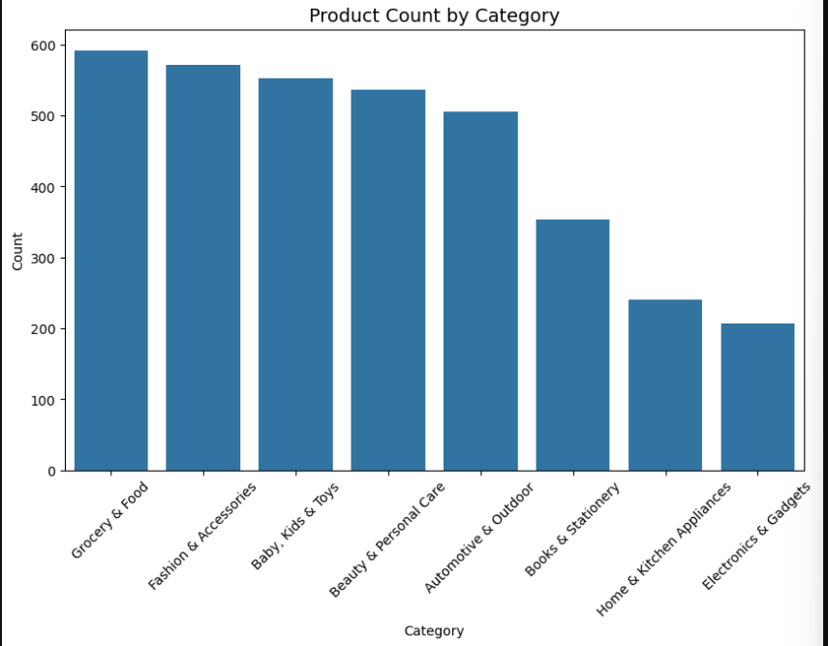

2.DISTRIBUTION OF PRODUCT PRICES
- Most products are clustered in the lower price range, meaning affordable items dominate the dataset.
- A few products are priced much higher, forming a right-skewed distribution with some expensive outliers.
- This pattern shows that Amazon’s product base is largely budget-friendly, with only a few premium-priced items.
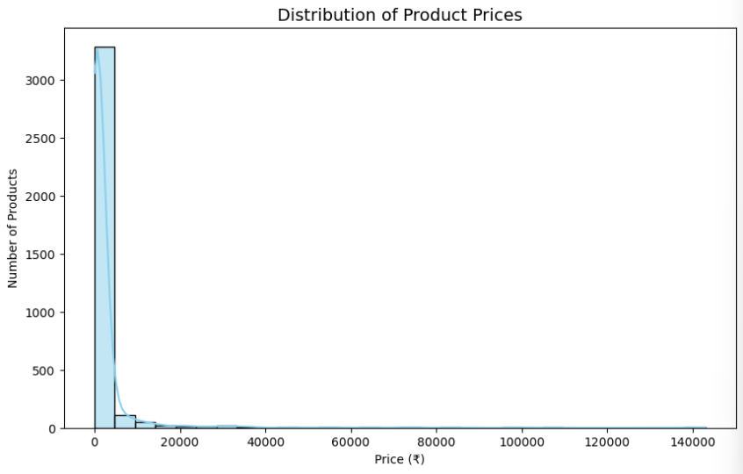
3. DISTRIBUTION OF PRODUCT RATINGS
- Most products have ratings between 3.5 and 5, showing overall positive customer satisfaction.
- Very few products fall below a rating of 3, meaning low-rated items are rare.
- The distribution suggests that customers tend to rate products favorably, possibly due to good product quality or positive shopping experiences.
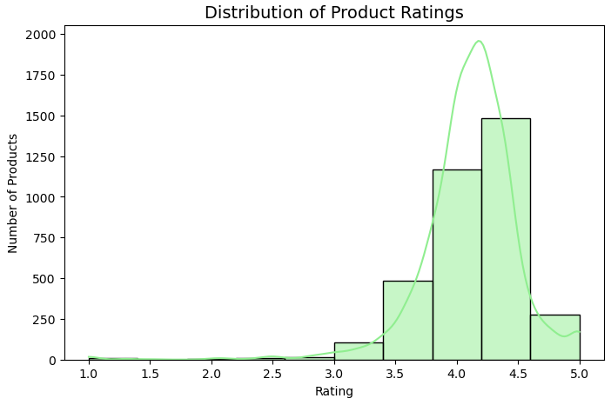

4. DISTRIBUTION OF OFFER PERCENTAGES
- Most products have moderate discounts (around 20–50%), indicating that mid-range offers are most common.
- Very high discounts (above 70%) are less frequent, showing they’re used selectively for promotions or clearance.
- The distribution shows that offers play a key role in attracting buyers but extreme discounts are relatively rare.
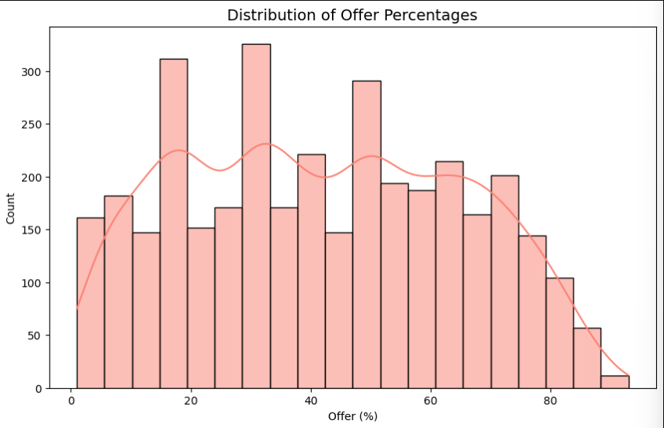
5.DISTRIBUTION OF SATISFACTION LEVELS
- Most products fall under “Good”, “Very Good”, and “Excellent”, showing generally high customer satisfaction.
- Very few products are in “Poor” or “Very Poor” levels, meaning negative experiences are uncommon.
- The chart highlights that Amazon’s product ratings and reviews reflect strong customer trust and quality standards.

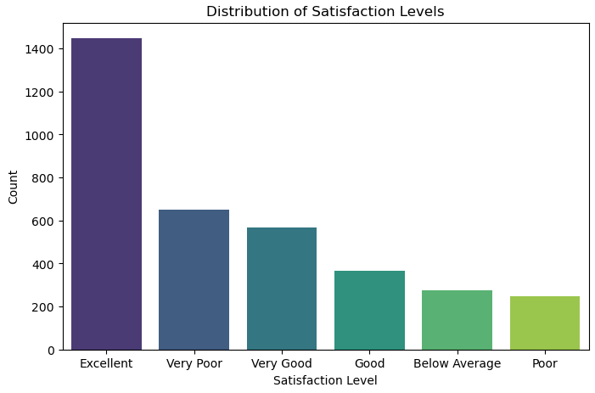

BIVARIATE
1.SATISFACTION LEVEL BY PRODUCT CATEGORY
- Categories like Grocery & Food and Beauty & Personal Care have more products in the “Very Good” and “Excellent” satisfaction levels, showing high customer happiness.
- Categories such as Electronics & Gadgets show a mix of satisfaction levels, indicating varying customer experiences.
- The chart helps identify which product categories perform best in terms of satisfaction, guiding improvement or marketing focus.
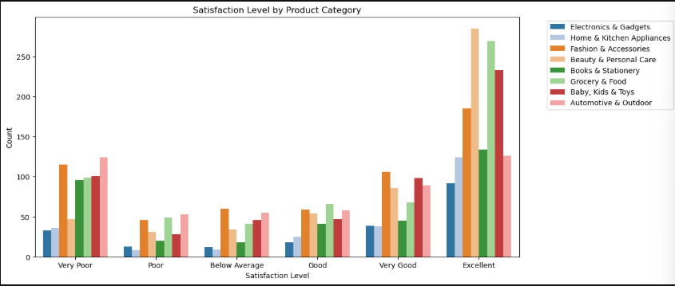
2.AVERAGE PRICE BY CATEGORY
- Electronics & Gadgets and Home & Kitchen Appliances have the highest average prices, showing these are premium or high-value categories.
- Books & Stationery and Grocery & Food have lower average prices, reflecting everyday and budget-friendly items.
- The chart clearly highlights pricing patterns across categories, useful for analyzing affordability and its effect on satisfaction.
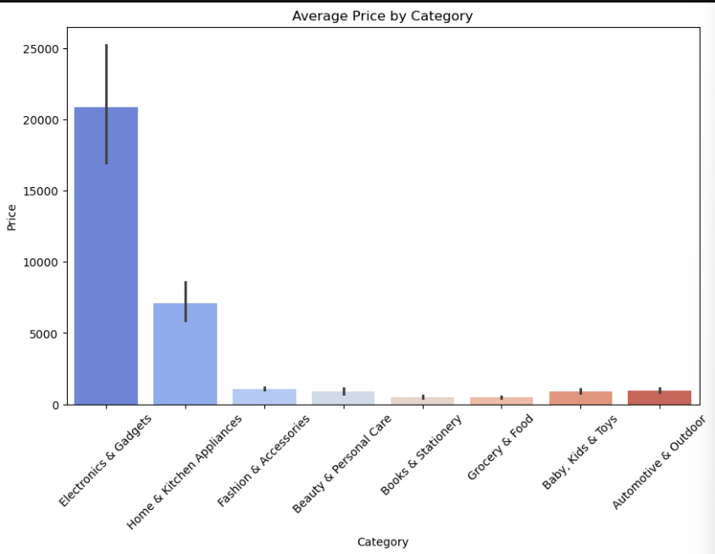
MULTIVARIATE:
1.PRICE VS RATING BY CATEGORY
- Products with higher prices don’t always have higher ratings, suggesting that price doesn’t guarantee satisfaction.
- Most highly rated products are mid-priced, showing that customers value affordability with quality.
- Some categories, like Electronics, show wider price variation, while others (like Books) stay in a narrow price range — reflecting category-specific pricing trends.
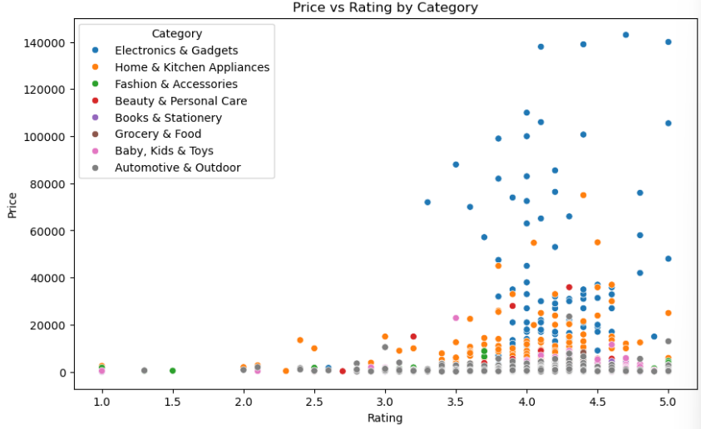
2.EFFECT OF DISCOUNT OFFER ON MONTHLY SALES
- As the offer percentage increases, the number of items bought last month also rises, showing a positive impact of discounts on sales.
- After a certain point, the increase may slow down, suggesting diminishing returns — extreme discounts don’t always boost sales much further.
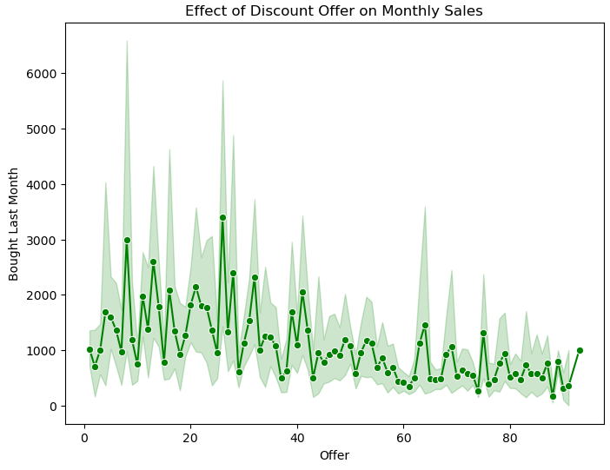
3.MONTHLY SALES BY CATEGORY AND RATING
- Categories like Grocery & Food and Fashion & Accessories show higher monthly sales, especially for highly rated products.
- Products with better ratings tend to have higher sales, confirming that customer satisfaction drives repeat purchases.
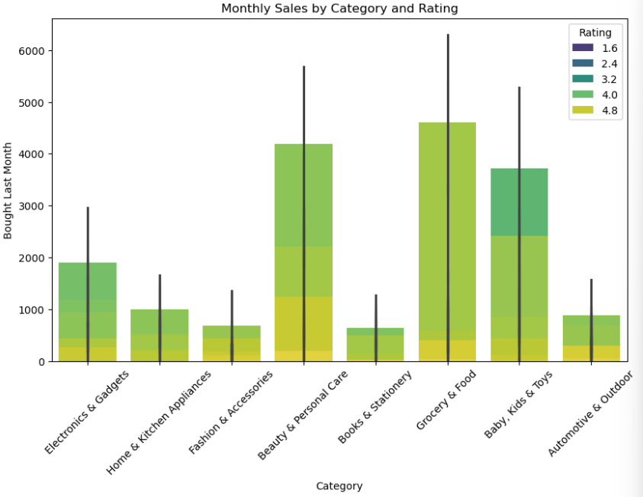
- Some categories, like Books & Stationery, show lower sales despite good ratings, suggesting niche demand or less frequent purchases.

SQL CONNECTIVITY
The SQL connectivity phase was implemented to integrate the cleaned dataset with a MySQL database for structured storage and easy data management. Using libraries like mysql.connector and pandas, a secure connection between Python and MySQL was established by providing necessary credentials such as host, username, password, and database name.
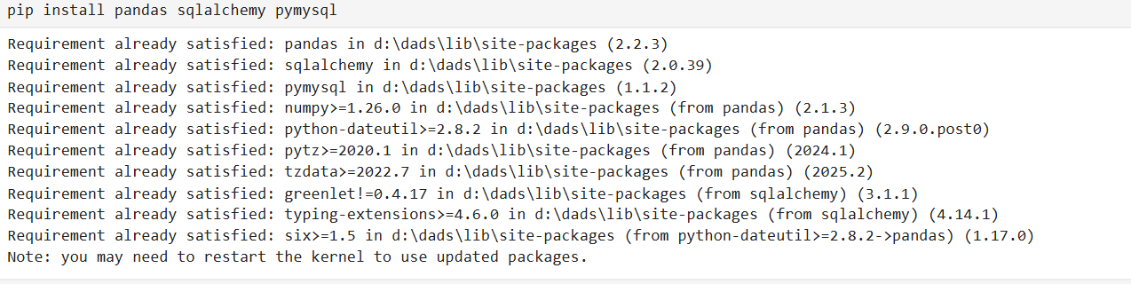
Once the connection was created, a new database was set up, and a table was designed with columns that matched the dataset, including attributes like Category, Product Name, Price, Rating, Number of Reviews, and Offer. Appropriate SQL data types were assigned to maintain data accuracy and structure.
The cleaned data from Python was then inserted into the table using the to_sql() method, enabling efficient transfer from a DataFrame to a relational database. SQL queries were executed to verify the records and explore the stored data — for example, counting entries, checking averages, and filtering based on conditions like product ratings or prices.

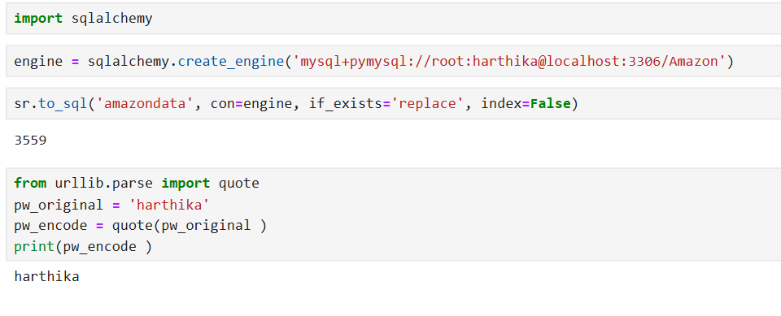
Finally, the connection was closed to ensure security and proper resource handling. This process helped bridge the analytical power of Python with the structured querying strength of SQL, allowing for better data accessibility, scalability, and integration in future analysis or visualization task
UNSUPERVISED LEARNING
Importing Libraries and Preparing Data for Clustering
The first cell imports essential libraries such as sklearn.cluster, matplotlib, and seaborn. The dataset containing features like Price, Rating, and Number of Reviews was selected for clustering. Before applying the algorithm, the relevant columns were isolated and standardized using StandardScaler to normalize feature values. This step ensures that all features contribute equally to distance calculations, as clustering algorithms are sensitive to scale differences.
K-MEANS ALGORITHM
Elbow Method for Optimal Cluster Selection
The next cell implements the Elbow Method to determine the ideal number of clusters (K). It runs the K-Means algorithm for multiple K values (for example, 1–10) and stores the Within-Cluster Sum of Squares (WCSS) for each. A line plot is then generated showing WCSS vs. K.
The “elbow point” in the graph — where WCSS starts to flatten — helps identify the optimal number of clusters, balancing accuracy and simplicity. This step is crucial to avoid overfitting (too many clusters) or underfitting (too few).
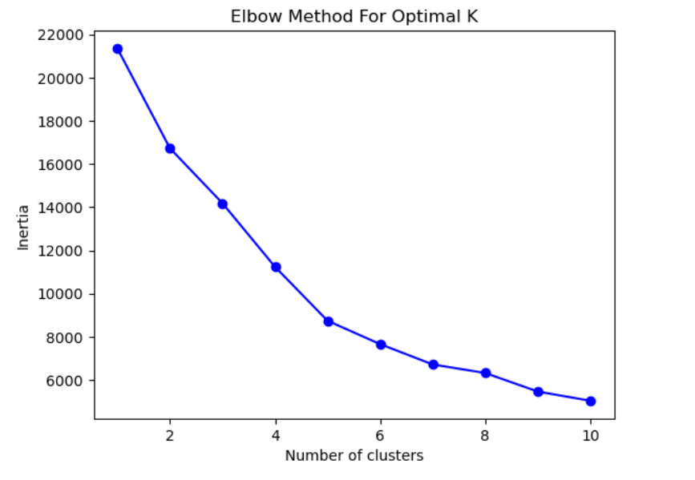

Implementing K-Means Clustering
After identifying the optimal number of clusters, K-Means is applied to the dataset. The algorithm groups similar records into K distinct clusters based on their feature similarities. Each data point is then assigned a cluster label, which is added as a new column to the dataset (e.g., Cluster_Label). This enables further comparison and interpretation of the groups.

Analyzing Cluster Characteristics
Finally, summary statistics are computed for each cluster to interpret their characteristics. The mean and median of key features like Price and Rating are calculated across clusters.
This step provides valuable business insights — for instance, identifying premium products that attract higher ratings or affordable products with more customer engagement.

SUPERVISED LEARNING
The supervised learning phase of the project focuses on building predictive models that can learn from labeled data and make accurate predictions on unseen data.
In this project, multiple machine learning algorithms were implemented — Logistic Regression, Support Vector Machine (SVM), Random Forest, K-Nearest Neighbors (KNN), and XGBoost — to compare their performances and identify the most efficient model.

DATA PREPARATION AND SPLITTING
Before training the models, the dataset was divided into features (X) and target (y). The target variable represented the output to be predicted (e.g., product category or label), while the features included all independent variables that influenced the target.
The data was then split into training and testing sets using an 80:20 ratio. The training set was used to fit the model, and the testing set was used to evaluate performance.
Additionally, feature scaling (StandardScaler) was applied to ensure all features were on the same scale, preventing algorithms like Logistic Regression, SVM, and KNN from being biased toward higher-valued features.

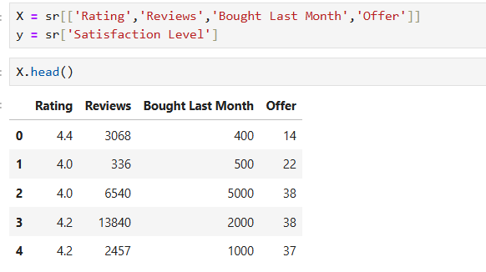
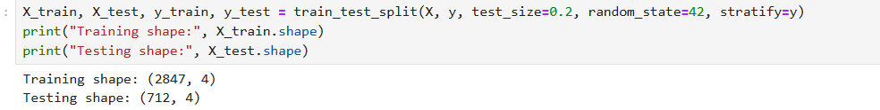

1. LOGISTIC REGRESSION
The Logistic Regression model was trained first to establish a baseline for classification accuracy.
It was chosen for its simplicity and interpretability, as it models the relationship between the dependent variable and independent variables using a logistic function.
Purpose:
To predict categorical outcomes by estimating probabilities based on linear combinations of the input features.
Observation:
The model achieved a moderate accuracy score, indicating that the dataset contained nonlinear relationships that logistic regression could not fully capture.
However, its coefficients provided valuable interpretability, helping identify which features most strongly influenced the predictions.

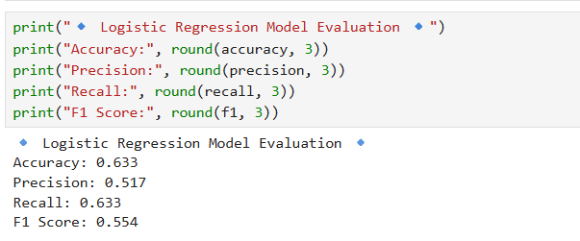

2.SUPPORT VECTOR MACHINE (SVM)
Next, a Support Vector Machine (SVM) model with an RBF kernel was implemented.
SVM aims to find the best decision boundary (hyperplane) that separates data points of different classes with maximum margin.
Purpose:
To handle complex, nonlinear relationships by transforming features into higher dimensions using kernel functions.
Observation:
The SVM model produced improved accuracy compared to Logistic Regression, demonstrating its strength in handling non-linear separations.
It achieved balanced performance in terms of precision, recall, and F1-score, suggesting that it effectively minimized both false positives and false negatives.

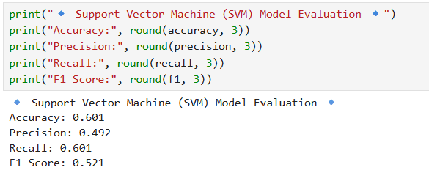

3.RANDOM FOREST CLASSIFIER
The Random Forest algorithm was then applied as an ensemble model that combines multiple decision trees.
Each tree learns from a random subset of the data, and their collective output enhances generalization.
Purpose:
To reduce overfitting and improve predictive stability through ensemble averaging.
Observation:
The Random Forest model outperformed both Logistic Regression and SVM, achieving higher accuracy and F1-score.
Its interpretability also allowed feature importance ranking, helping identify which factors contributed most to predictions.
The model handled missing and categorical data effectively and generalized well across the test data.

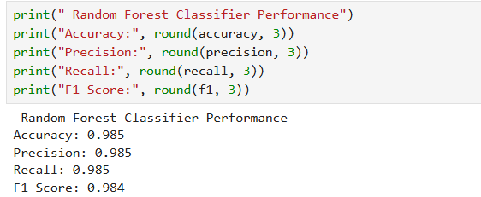

4.K-NEAREST NEIGHBORS (KNN)
The KNN algorithm was implemented as a non-parametric, instance-based learning model.
It classifies data points based on the majority class among their nearest neighbors.
Purpose:
To capture local patterns in the dataset by comparing feature similarity between instances.
Observation:
KNN achieved reasonable accuracy but was slightly less efficient compared to Random Forest and XGBoost.
Since it relies on distance computation, the algorithm was sensitive to scaling and outliers.
Despite this, KNN provided insights into data distribution and class density within the feature space.

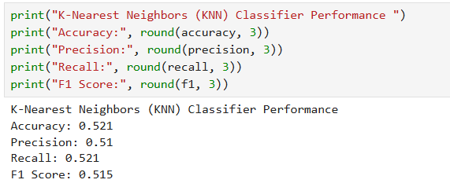

5.XGBOOST CLASSIFIER
Finally, the XGBoost model was implemented, known for its efficiency and high performance in structured datasets.
It uses gradient boosting, where weak learners (decision trees) are iteratively improved by minimizing prediction errors.
Purpose:
To achieve optimal predictive performance by combining boosting techniques with regularization to prevent overfitting.
Observation:
The XGBoost model achieved the highest accuracy and F1-score among all models, proving to be the most robust and well-generalized.
It effectively handled both linear and nonlinear patterns, learned feature interactions efficiently, and demonstrated strong generalization on test data.
This model was selected as the best-performing model for this dataset.

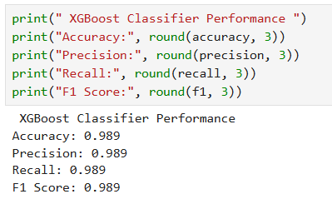

HYPERPARAMETER TUNING
After identifying the best-performing models from initial testing, the next critical step in model optimization was hyperparameter tuning. This process fine-tunes the parameters that control the model’s learning process to achieve higher accuracy, better generalization, and optimal performance. Unlike model parameters learned during training, hyperparameters are predefined and must be set before the training process begins.
The goal of hyperparameter tuning is to determine the ideal combination of values that minimizes prediction error and prevents both overfitting and underfitting. By systematically exploring multiple configurations, the model’s predictive performance can be significantly improved without altering the dataset itself.
1. Purpose of Hyperparameter Tuning
Each machine learning model has its own set of hyperparameters:
- Logistic Regression: Regularization strength (C) and solver type influence the convergence and handling of multicollinearity.
- SVM: Kernel type, regularization (C), and gamma control the decision boundary’s flexibility.
- Random Forest: Number of trees (n_estimators), maximum depth, and minimum samples per split affect ensemble strength and model variance.
- KNN: Number of neighbors (n_neighbors) and distance metrics determine model sensitivity to nearby data points.
- XGBoost: Learning rate (eta), number of estimators, and maximum depth are key to balancing bias and variance.
By tuning these parameters, the project aimed to enhance performance consistency and avoid overfitting, ensuring that the model generalizes well to unseen data.

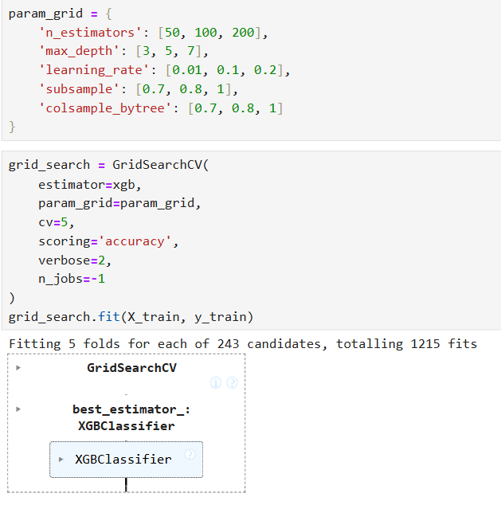
2. Approach Used
For tuning, Grid Search Cross-Validation (GridSearchCV) was employed.
This method exhaustively tests all possible combinations of specified hyperparameter values and selects the configuration that yields the highest cross-validation score.
The cross-validation ensures that the model’s performance is evaluated across multiple folds of the dataset, providing a reliable estimate of how the model would perform on new, unseen data.
Example workflow for tuning:
- Define a parameter grid for each model (e.g., varying learning rates, depth, and estimators).
- Apply GridSearchCV with 5-fold cross-validation.
- Fit the model on training data and identify the best parameter set.
- Re-train the model using the optimized parameters.

3. Results and Observations
After applying hyperparameter tuning:
- XGBoost demonstrated the most improvement, achieving the highest accuracy and F1-score among all models.
- Random Forest performance became more stable, reducing overfitting after optimizing tree depth and the number of estimators.
- SVM improved slightly in precision and recall after tuning C and gamma values.
- KNN performance increased modestly with optimal k value selection.
The tuned models were re-evaluated, and results confirmed that the optimization process enhanced predictive capability without compromising model interpretability.

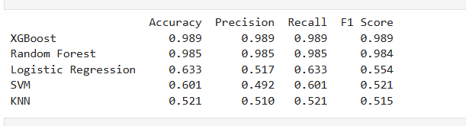
PREDICTION & CONCLUSION
In this phase, all the trained machine learning models — Logistic Regression, SVM, Random Forest, KNN, and XGBoost — were used to make predictions on the test dataset. The prediction process involved applying the .predict() function on the unseen test features (X_test or X_test_scaled depending on the model).
Each model generated predicted values (y_pred) based on the patterns it learned during training. These predictions were then compared with the actual target values (y_test) to assess model performance using metrics such as Accuracy, Precision, Recall, and F1-Score.
The process helped to determine how well each model generalized to new data. For example:
- Models like Logistic Regression and SVM predicted effectively for linearly separable data.
- Random Forest and XGBoost handled complex, non-linear relationships better, leading to higher accuracy.
- The KNN model performed reasonably well after fine-tuning parameters like the number of neighbors.

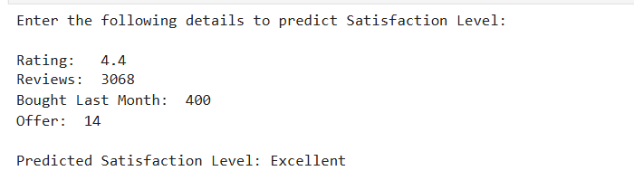

Insights and Observations
The prediction results revealed clear differences in model performance:
- XGBoost produced the highest accuracy and F1-score, proving to be the most robust and reliable model for this dataset.
- Random Forest showed strong predictive capability with slightly less accuracy but better interpretability.
- SVM and Logistic Regression provided consistent results, confirming that the data preprocessing and scaling steps were effective.
- KNN demonstrated moderate accuracy, indicating sensitivity to data scaling and neighborhood size.
Overall, the prediction phase validated that the models could effectively learn and generalize patterns from the dataset. It also confirmed that proper preprocessing, scaling, and hyperparameter tuning significantly improved prediction performance and model stability.
